Key Stage 2 Expected Standard Outcomes 2016/2017* 2017 yet to be validated

Attainment % | Reading |  | Writing |  | GP&S |  | Maths |  | Combined
 | 2016 | 2017 | 2016 | 2017 | 2016 | 2017 | 2016 | 2017 | 2016 | 2017
School | 80 | 73 | 80 | 70 | 80 | 77 | 88 | 73 | 68 | 50
Cornwall | 66 | 76 | 73 | 76 | 68 | 78 | 65 | 72 | 51 | 59
National | 66 | 71 | 74 | 76 | 73 | 77 | 70 | 75 | 53 | 61

Key Stage 2 Greater Depth Standard Outcomes 2016/2017 * 2017 yet to be validated

Attainment % | Reading |  | Writing |  | Maths
 | 2016 | 2017 | 2016 | 2017 | 2016 | 2017
School | 40 | 30 | 12 | 30 | 28 | 20
Cornwall | 20 | 24 | 16 | 20 | 13 | 17

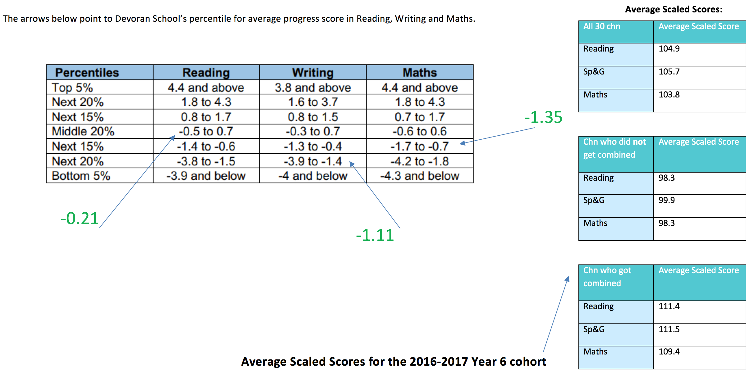
Average Scaled Scores:
All 30 chn | Average Scaled Score
Reading | 104.9
Sp&G | 105.7
Maths | 103.8

Chn who did not get combined | Average Scaled Score
Reading | 98.3
Sp&G | 99.9
Maths | 98.3

Chn who got combined | Average Scaled Score
Reading | 111.4
Sp&G | 111.5
Maths | 109.4

Average Scaled Scores:
All 30 chn | Average Scaled Score
Reading | 104.9
Sp&G | 105.7
Maths | 103.8

Chn who did not get combined | Average Scaled Score
Reading | 98.3
Sp&G | 99.9
Maths | 98.3

Chn who got combined | Average Scaled Score
Reading | 111.4
Sp&G | 111.5
Maths | 109.4

