Community news

Trevince Pheasant-Feather
Wreath-Making Workshop
Wednesday 31st October - 0900 to 1230

Based in the Victorian Stable Yard at Trevince, under the tuition and guidance from Trish Stone (Owner and Director of Trevince), a morning’s workshop of enjoyable new skills learnt and hopefully, new friendships made.
Or perhaps if you're too busy? – An Opportunity to order your own wreath in advance for collection during our 'Country House Christmas' Event in December [Dates below]
WORKSHOP DETAILS:
DATE: Wednesday 31st October
WORKSHOP TIMES: 09:00 to 12:30
COST: £45 per person - To include: tuition, materials, delicious refreshments and your own Pheasant Feather Wreath to take home with you
WHERE: Trevince Victorian Stables and Coach House, Trevince, Gwennap. TR16 6BA
THE MORNING’S TIMETABLE:
09:00: Arrival, meet your fellow workshop wreath-makers over a welcoming cuppa
10:00: Trish will give a brief talk about the 'history' behind her Pheasant Feather Wreath making and a demonstration on how to start making your own Pheasant Feather Wreath
10:30 to 12:30: Time to give it a go! Make your own pheasant feather wreath, with guidance from Trish
Further coffee / tea and delicious cakes served mid-morning before proudly taking your Pheasant Feather Wreath home with you.
HOW TO BOOK YOUR WORKSHOP:
Email our Events Co-Ordinator, Nicki - njohn@trevince.co.uk to book your place.
Nicki will send you an invoice, by return of email. (Payment of the full amount, will both confirm and secure your place on the 'Pheasant Feather Wreath Workshop')
TOO BUSY TO JOIN THE WORKSHOP?
You are welcome to order a Pheasant Feather Wreath for just £30 (per wreath), made especially for you in advance of collecting during our 'Country House Christmas' event: 30th November, 1st and 2nd December and the following weekend - 7th to 9th December.)
TO ORDER YOUR PHEASANT FEATHER WREATH: Simply email Nicki to confirm your order and choose which date you'd like to collect your wreath, during our 'Country House Christmas' event.
HOW TO GET HERE: Directions: http://www.trevince.co.uk/directions
ANY QUESTIONS?:
Please feel free to contact Nicki: njohn@trevince.co.uk or Telephone the office: 01209 822 72
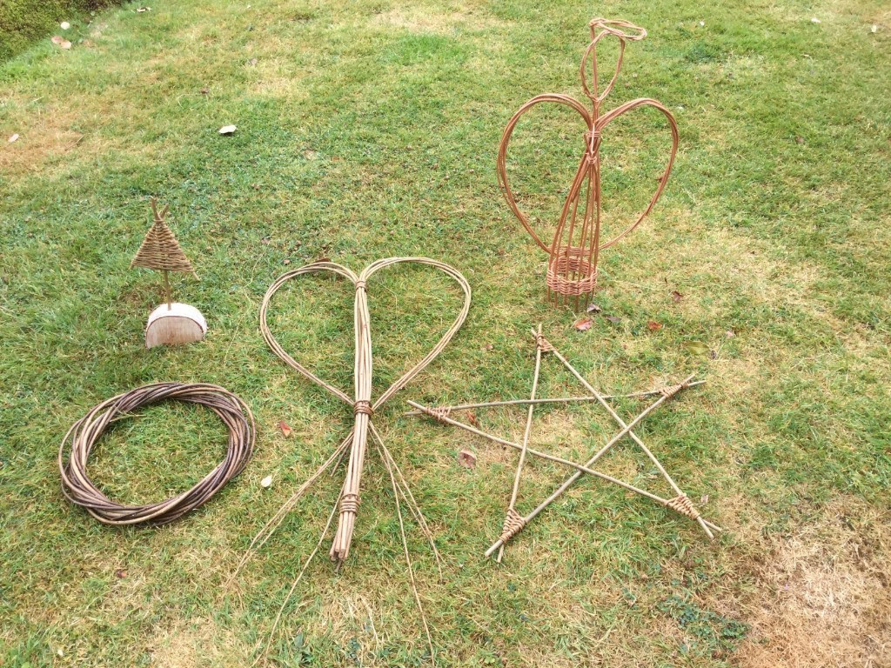

Christmas Willow-Making Workshop
Thursday 8th November - 0930 to 1630
Trevince Victorian Stables

Come join us for a full day's workshop, with our expert Willow Maker - Lynn Kentish
Based in our delightful Victorian Stables, Lynn will teach you how to make a selection of Christmas willow shapes to take home and use this Christmas!
A Willow Wreath, to decorate with foliage or fairy lights
A Willow Star or Angel, to place on top of your Christmas tree
A Mini Willow Christmas Tree, to decorate yourself &
A Willow Heart, to give to a loved one
All this fun along with refreshments, a light luncheon and a glass of something fizzy and hopefully new friendships made

Would you like to enter the Truro Christmas Prime Stock’s 116th Show?..! Please read the below information to find out more about deadlines and sections:
Truro Christmas Prime Stock & Produce Society
President: HRH The Countess of Wessex GCVO

Schedule of Classes
116th Show
---------- 1902-2018 ----------
The Marquee, Lemon Quay, Truro
Wednesday 5th December 2018

Cattle ● Sheep ● Dressed Lamb Carcass● Hay ● Silage ● Grain ● Roots ●
Vegetables ● Apples ● Eggs ● Cookery ●Preserves ●Floral Art ● Handicrafts ● Honey ●Photography ● Children’s Classes ● YFC ● WI ●

Please return all entries to the school no later than Friday 2nd November 2018

Children’s Section
(No Entry Fee) Judge: Mr A. Bowyer
Mrs N. Abbott
Competitors in Classes 136- 138 must be Yr.R, Yr.1 or Yr.2. Age to be stated on entry

136. A Leaf Picture – A4
137. Handwriting – ‘Twinkle Twinkle Little Star’ 1st Verse
(Mounted, Maximum A4, No decoration, In pencil)
138. An Item Made from Egg Boxes – maximum space 30cm x 30cm (12” x 12”)

Competitors in Classes 139 - 141 must be in Yr.3 or Yr.4. Age to be stated on entry.

139. A Paper Snowflake – Maximum A4
140. Handwriting – ‘We Wish You a Merry Christmas’ 3 Verses (Mounted, maximum A4, on plain or lined paper, no decoration)
141. A Decorated Plant Pot , max 13cm (5”)

Competitors in Classes 142 - 144 must be in Yr.5 or Yr.6. Age to be stated on entry.

142. An Item Made from Fir Cones – Max 30cm x 30cm (12” x 12”)
143. Handwriting – The National Anthem – 1st and 2nd verses.
(on plain or lined A4 paper, mounted, no decoration, in pen, joined)
144. An Invitation to a Royal Wedding - Computer Aided. A4 size

IMPORTANT NOTE: 1 ENTRY PER CLASS
(9 classes) TOTAL 9 ENTRIES PER SCHOOL
INDIVIDUAL ENTRIES WELCOME
PRIZES
A Perpetual Challenge Cup is awarded to the school with most points overall.
A £15 Book Token is awarded to the school with most points in each age section.
A Cup is awarded to the Best Overall Exhibit.
Trophies to be won outright for the Best Handicraft, Best Picture /Painting/ Poster, Best Handwriting, in comparative classes.
Age will be taken into consideration.

Additional Information for Schools or Individual Entries
- Maximum of 1 entry per school in each class.
- Prize money is not awarded in this section. Prize cards are given for 1st, 2nd & 3rd places in
each class.
- If entries are mounted, then we request single mounted only not exceeding 2cm width.
- A label stating the entrant’s name, age, school and class number entered must be
attached to the rear of each entry. Entries must be individual efforts and not group work.
- Each School (or individual) is asked to submit a list of entrants names with the class
numbers entered.

Mr Morgan is taking part in The Three Peaks Challenge!
The Challenge: To hike up the three highest peaks in Scotland, England and Wales, all in 24 hours.
Ben Nevis (Scotland) stands at 1,345m
Scafell Pike (England) stands at 978m
Mount Snowdon (Wales) stands at 1,085m
We aim to start at Ben Nevis in Scotland on Saturday 13th October. After completing this, we will travel to the Lake District region of England to take on Scafell Pike overnight. Upon completing this in the early hours of Sunday morning on the 14th October, we will travel to Mount Snowdon in Wales to finish the challenge by midday!

The Invictus Trust (charity number 1143954) is a Cornwall based charity that supports adolescents with mental health issues.
To find out more about the Invictus Trust, visit www.invictustrust.co.uk
As well as online fundraising, the team are also working hard to raise money for this amazing cause with the help of many local business in Falmouth, Cornwall.
To find out more or to make a donation to this great cause, please use the following link:
https://uk.virginmoneygiving.com/fundraiser-display/showROFundraiserPage?userUrl=The-Peaky-Climbers&pageUrl=2&isTeam=true

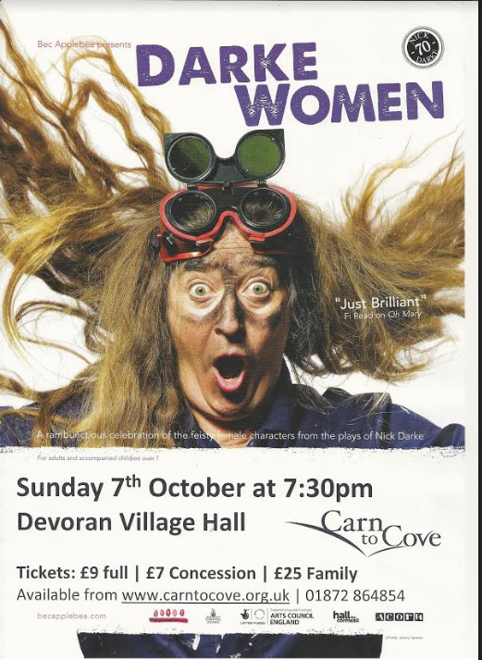
Please bring your own snacks and drinks!

