

**KEYWEAR** are taking their annual 2 week holiday from Friday 2nd March to Saturday 17th March.

**There is cover in the shop week beginning 5th March on Monday, Wednesday and Thursday and the following week 12th March again Monday Wednesday Thursday**.

Outside of these times parents can order online 24/7 at [www.keywearuniforms.co.uk](http://www.keywearuniforms.co.uk/). Choosing either, Click and collect on the days we are open. Or their order mailed directly to their home address.

[**www.keywearuniforms.co.uk**](http://www.keywearuniforms.co.uk/)



**Community news**



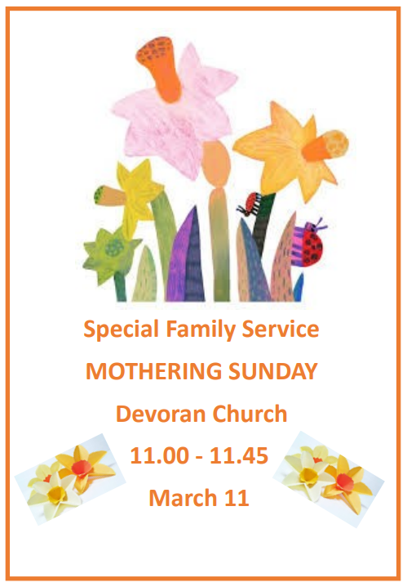

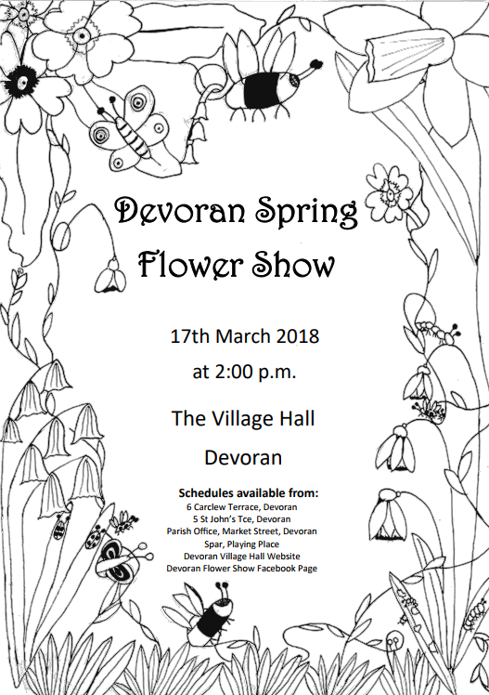

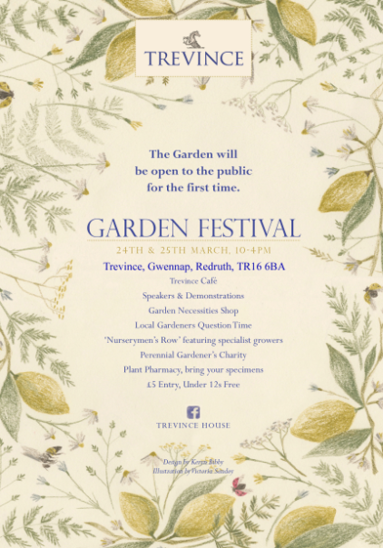



**Drama Workshop  
@ The Burrell Theatre  
  
Date:3rdApril  
 Time: 08:30 – 17:00  
Age: 6 – 14 Years   
Cost: £25 (includes hot lunch)**

**This workshop will give your child the opportunity to make friends, have fun and develop some great skills led by our experienced team within the Burrell Theatre at Truro School.  
Your child does not need any previous dancing, singing or acting experience, just a willingness to have a go and have fun.**For more information and an application form please visit our website:  
 www.sirbenainsliesportscentre.com



|  |  |  |  |  |  |  |  |
| --- | --- | --- | --- | --- | --- | --- | --- |
| |  |  |  |  |  |  |  | | --- | --- | --- | --- | --- | --- | --- | | |  |  | | --- | --- | | |  | | --- | | 'Illustration Masterclass' with Caroline Pedler | |  |  |  | | --- | --- | | |  | | --- | | https://gallery.mailchimp.com/919c04d60f3bffd08bfcdb0fa/images/1df54b05-22ab-4989-8f6d-d3c8909f6e46.jpg | |  |  |  | | --- | --- | | |  | | --- | | Monday 9th April - 10am - 4pm - £48 | | | |
| |  |  |  |  |  |  |  |  |  |  |  |  | | --- | --- | --- | --- | --- | --- | --- | --- | --- | --- | --- | --- | | |  |  |  | | --- | --- | --- | | |  |  | | --- | --- | | |  | | --- | | Join published author Caroline Pedler in this illustration masterclass. She’ll show you how to get a project going, guiding you through creating a narrative, producing thumbnail artwork and ultimately a complete book. | | |  |  |  |  | | --- | --- | --- | | |  |  | | --- | --- | | |  | | --- | | Caroline is a Cornish illustrator, fine artist and lecturer. As well as exhibiting her fine art work throughout Cornwall she has illustrated and published over 50 books which have been translated into 23 different languages worldwide. | | |  |  |  | | --- | --- | | |  | | --- | |  | |  |  |  | | --- | --- | | |  | | --- | |  | |  |  | | --- | |  | | |

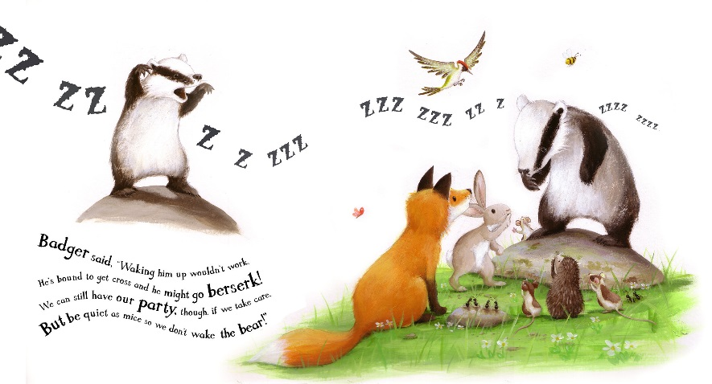

|  |
| --- |
| **If you would like to book a place please give us a call on 01872 240 567.** |

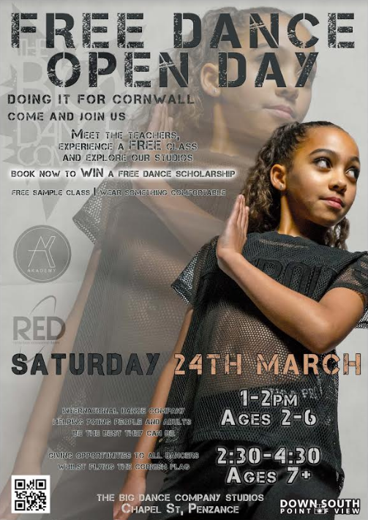

Trevada Music's Camborne store will once again be taking part in the National Learn To Play Day on Saturday 17th March. We will be offering free taster lessons in our store throughout the day.

Lessons are available to adults and children of any age with the chance to try Guitar, Violin, Piano, Flute, Clarinet, Saxophone, Oboe, Bassoon, Trumpet, Cornet, Flugel Horn, Tenor Horn, Baritone Horn, Trombone, Euphonium, Tuba and Drums!! Instruments will be provided where needed. We are also offering vocal lessons for budding singers.

If you or anyone you know has ever wanted to have a go at a particular instrument then here is your chance to try for FREE with a qualified tutor.

Please book your slot early to avoid disappointment by calling 01209 714353 with your chosen instrument and your contact details.

Trevada Music Ltd  
[9 Chapel Street](https://maps.google.com/?q=9+Chapel+Street+Camborne+Cornwall+TR14+8EF&entry=gmail&source=g)  
[Camborne](https://maps.google.com/?q=9+Chapel+Street+Camborne+Cornwall+TR14+8EF&entry=gmail&source=g)  
[Cornwall](https://maps.google.com/?q=9+Chapel+Street+Camborne+Cornwall+TR14+8EF&entry=gmail&source=g)  
[TR14 8EF](https://maps.google.com/?q=9+Chapel+Street+Camborne+Cornwall+TR14+8EF&entry=gmail&source=g)

Tel:  [+44 (0)1209 714353](tel:%2B44%20%280%291209%20714353)  
[www.trevadamusic.co.uk](http://www.trevadamusic.co.uk/)





**Drama Workshops for Girls 5-11**

Fun and engaging drama workshops with an experienced tutor; it's a great way to build confidence, be creative and to make new friends. Join us now to take part in our summer show. Why not come along for a free taster session?

£3/session.

Pottery Preschool on Chapel Hill.

Saturdays 10-11 (term-time only).

Contact Shibon 07873 669798 or find us on facebook *Inspiring Women Network*.

From Nourallah Chakroun

**Inspiring Women Network**

[**www.inspiringwomennetwork.co.uk**](http://www.inspiringwomennetwork.co.uk/)

**Telephone:07999327717**

**E-mail address:**[**inspiringwomennetwork@gmail.com**](mailto:inspiringwomennetwork@gmail.com)

**Facebook:**<https://www.facebook.com/groups/503893046305800/>

The 2018 Devoran Spring Flower Show will be held on **Saturday 17th March at 2pm**.   
Entries must be submitted by Tuesday 13th March, and displayed in the Village Hall on the Saturday morning.  
There are some exciting new classes this year, as well as the old favourites - schedule and further details available soon. Please note the date for your diaries

In conjunction with the Truro BID team, we are having a City Clean Up during the week **Tuesday 3rd April - Saturday 7th April**. We want to cover as much of the City as we can and are after volunteers to get involved by helping in their own neighbourhoods. An hour, half a day, whatever time can be spared will be most welcome. We will supply hi-vis vests, gloves, bags and litter sticks. Children are most welcome to participate if they are under the direct control of their parent or guardian. Interested?   Then email [cleantruro@gmail.com](mailto:cleantruro@gmail.com) with the following details:

Name:

Contact e mail address:

Mobile Tel No:

Area(s) you would like to get involved in:

What day/date/time you can spare:

All litter collected will either be recycled or disposed of appropriately.

Thank you in anticipation

Paul Caruana

Community Volunteer Coordiantor

|  |  |  |  |  |  |
| --- | --- | --- | --- | --- | --- |
| |  |  |  |  |  | | --- | --- | --- | --- | --- | | |  |  | | --- | --- | | |  | | --- | | **LEARN TO DRAW: PENCIL PORTRAITURE WITH TAMSIN DEARING** | |  |  |  | | --- | --- | | |  | | --- | | Tuesday 10th April 10am - 4pm £50 | | | |
| |  |  |  |  |  |  |  |  |  | | --- | --- | --- | --- | --- | --- | --- | --- | --- | | |  |  |  | | --- | --- | --- | | |  | | --- | |  |  |  | | --- | |  | |  |  |  | | --- | --- | | |  | | --- | | In this fun and relaxed workshop you will explore the foundations of drawing lifelike portraits and receive expert tips to improve your observation and shading. Tamsin will build your drawing confidence by helping you see what is there and to accurately capture that on paper. Tamsin is a self-taught professional artist with a fascination for the stories every individual face can tell. This workshop is perfect for helping you overcome the fear factor in drawing likenesses and give you the confidence you need to develop your skills.  **Tamsin supplies everything for this workshop, however if you would like to use your own pencils and paper you can. Also, if there is a particular person you would like to draw please bring along an image.** | |  |  |  |  | | --- | --- | --- | | |  |  | | --- | --- | | |  | | --- | | **THERE IS LIMITED SPACE ON THIS WORKSHOP - IF YOU WOULD LIKE TO COME ALONG, GET IN TOUCH SOON BY CALLING US ON 01872 240 567 OR POP IN AND SEE US.** | | | | |

